PRT262S T2 Individual Assignment

221190384

Project 2 term 2 assignment

Sheldon Luke Arendse

2023

**Event-uality Entity Relationship Diagram (ERD)**_____________________________________________

111 **– My Table**   
111 **– Shared Table**

***Event Table***  
___________________________________________

We each have one sub-table that we are responsible for, with that being said, we decided to share the main table named Event. This decision was made to allow us to equally distribute the workload amongst all members of the group.

The Event table is responsible for all necessary information for an event created. The information that the Event table provides us with are the host, name of the event, description of event, time, date, location, status of approval and the ticket price.

***Attributes***  
___________________________________________

* **Event ID (String(8))** - Unique combination of characters and numbers
* **Event Type (String(40))** - the category of the event
* **Leader (Integer(8))** - Creator or host of the event
* **Title (String(40))** - The name of the event
* **Description (String(40))** - A detailed portrayal of the event
* **Time (Time)** – Time of the event (Start)
* **Date (Date)** - Day of the event (Start)
* **Location (String(40))** - Where event will be held
* **Is Approved By (Integer(8))** – Who gave the student permission to commence with event
* **Ticket Price (Integer)** – Admission fee requested by event creator, can also be non-profit
* **Approval Status (Boolean)**  – Status of event (Approved/Denied)

# **Events Table Sample Data**

|  |  |  |  |  |  |  |  |  |  |
| --- | --- | --- | --- | --- | --- | --- | --- | --- | --- |
| Event_ID | EventType | EventLeader | Title | Description | Time | Location | Approved_by | Approval_Status | Date |
| 7WIJOH25 | Agriculture | 37286105 | Farming | Teaching students how to grow their own crops at home | 10:30:00 | LEC119 | 34186297 | TRUE | 8/22/2023 |
| U1KQ2XNM | Sports | 71054396 | Soccer | Friendly 5-a-side tournament | 17:00:00 | BELHAL | 51379268 | FALSE | 9/11/2023 |
| ZHL6KOI9 | Education | 09248716 | Coding Bootcamp | Introductory course to Website development | 12:00:00 | CPTHAL | 98271450 | TRUE | 10/30/2023 |
| T17C2JDF | Culture | 36259478 | Poetry Slam | Allowing students to show off their poetry skills | 18:00:00 | CPTHAL | 27463518 | TRUE | 11/8/2023 |
| HABKEYSM | Social | 18274653 | 1st Year Social | Games day for 1st years to make new friends | 14:00:00 | LEC119 | 72304598 | TRUE | 11/14/2023 |
| Q50DJI87 | Social | 49508127 | Amazing Race | Scavenger hunt for a prize | 10:30:00 | BSPRUB | 82390715 | FALSE | 4/1/2024 |
| 7XFTYD2A | Education | 78156324 | Elective Workshop | Showing 1st years exciting aspects of each elective for 2nd year | 15:00:00 | CPTHAL | 30146578 | TRUE | 4/20/2024 |
| WM5COHUY | Arts & Culture | 85019473 | Chess Tournament | Friendly chess tournament for a small prize | 13:00:00 | BELLIB | 92031578 | FALSE | 5/18/2024 |
| O5Q10HC4 | E-Sports | 89536142 | Call of Duty LAN | Gaming tournament for a prize pool | 10:30:00 | CPTHAL | 49712583 | FALSE | 8/13/2024 |
| HOBX1DUP | Arts & Culture | 12036489 | Woodwork | Students are taught how to build basic things out of wood | 11:00:00 | BELLIB | 51902647 | TRUE | 11/21/2024 |

***Volunteer Table***  
___________________________________________

I am responsible for the Volunteer table. This table is used to hold the data and identify the students that have registered to be a volunteer for an event. Students are volunteered via the Student table.

The Volunteer table consists of 3 attributes namely, studentNumber, role and event ID. The primary key for this table is studentNumber. Event ID is a foreign key that is inherited from the primary key of the **Event table.**

StudentNumber is a unique identifier that shows the student who is volunteering for a particular event.   
The Role attribute is the title of the student’s job in the event. Event ID is a foreign key that relates a volunteer to a specific event or an event that they are registered for.

The volunteer table will keep track of students that are registered and pin them to each event that they are registered for.

***Attributes***  
___________________________________________

* **Student Number (Integer(8))** – unique number that identifies the student
* **Role (String(40))** – Name of the responsibility the student is registered for
* **Event ID (String (8))** – Unique combination of characters and numbers

***Volunteer Table Sample Data***  
___________________________________________

|  |  |  |
| --- | --- | --- |
| **Student_Number** | **Role** | **Event_ID** |
| 22128732 | Ticket Sales | 7WIJOH25 |
| 31345791 | Facilitator | U1KQ2XNM |
| 72313455 | IT Assistant | ZHL6KOI9 |
| 52837403 | Sound & Lights | T17C2JDF |
| 21398552 | Team Leader | HABKEYSM |
| 21424662 | Instructor | Q50DJI87 |
| 42434112 | IT Assistant | 7XFTYD2A |
| 21334455 | Facilitator | WM5COHUY |
| 23456784 | Commentator | O5Q10HC4 |
| 21434465 | Safety Officer | HOBX1DUP |

**Please Note: All members participated in the selection of colors, fonts, components, and layout**

***Home Page***  
___________________________________________

The home page is a simple welcome page that gives the user some insight as to what our application does. The user can navigate through our application using our navigation bar.

***Login Page***  
___________________________________________

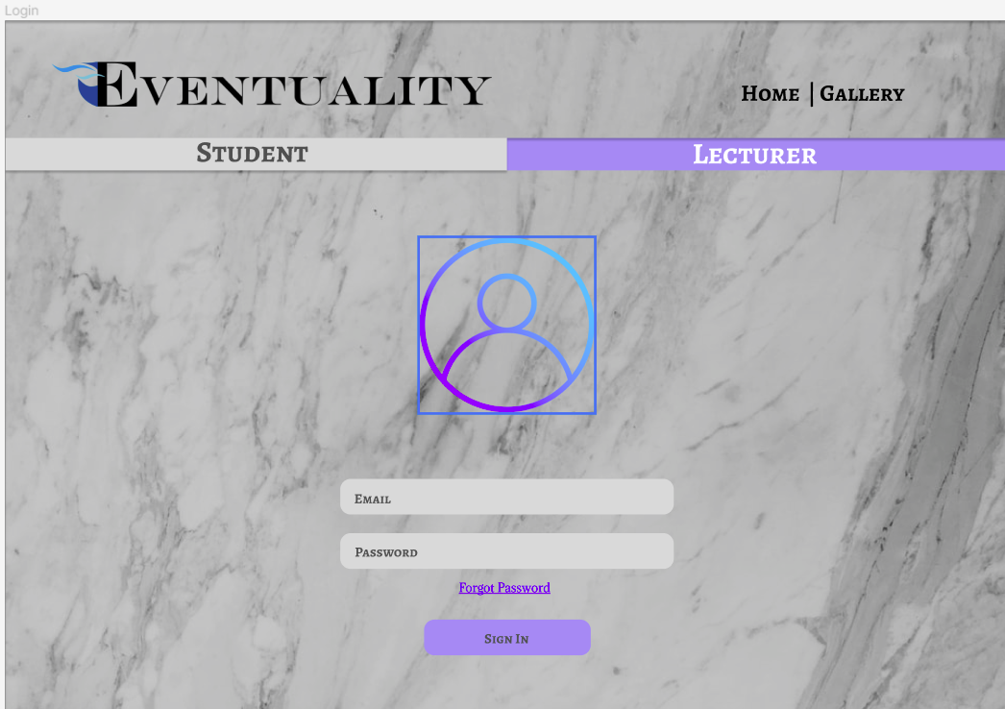Once the user has clicked on the “Sign In” option on the home page, the login page will display.   
The user can either login as a student or lecturer. If the lecturer tab is selected, the user will be prompted to login using the email and password associated with said lecturer. The login details will be checked via our database to see if it correctly corresponds. If the login details are correct, the lecturer will be granted access to the system with the role of a “Lecturer”. Students will experience the same login process, the only thing that changes is that they will be logged in as a “Student”.

***Events Page***  
___________________________________________

The volunteer table that I am responsible for is present in the “Create Event” block.

**This page has 3 functions:**

* An event can be created by filling out the form in the top left
* Users are able to view the events that they have booked tickets for
* Users are able to view and make changes to the event that they created, and view its status for approval
* This events page shows up once the user logs in. Students are only allowed to create one event that needs to be approved by a lecturer before it can commence. All information is checked by the system for its validity before the form is submitted.
* Students can also check the status of their created or participating event. The system will notify the user when their event has been approved or denied by the lecturer.
* Lecturers are able to see their booked event
* 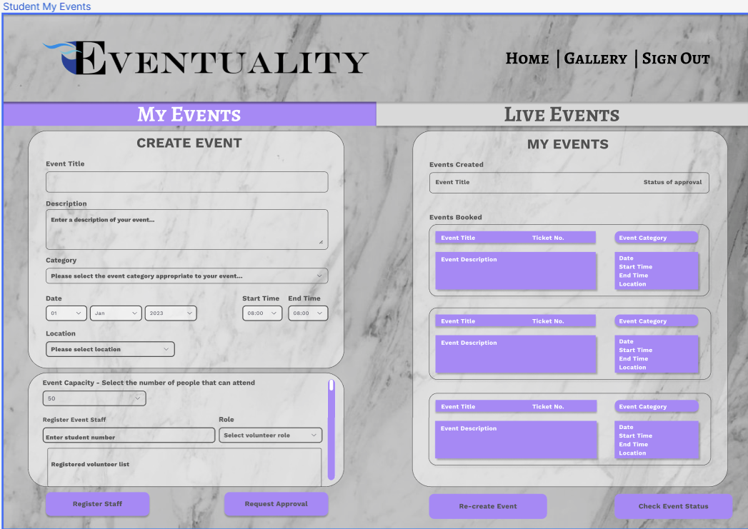The students table is connected to the events table by providing the students’ credentials for the event that they are volunteering for.

***Students Live Events Page***  
___________________________________________

* This page shows live events and events created. It will be populated once the student has either joined an approved event or created an approved event.
* This page makes a request to the Events table to gather data for previously approved requests
* Once the user clicks on event, the full details of the event will display.

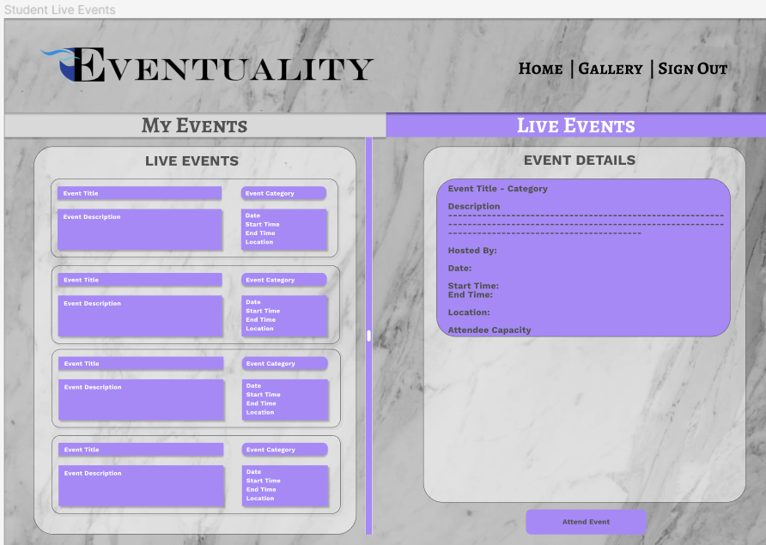

***Business Rules***  
___________________________________________

1. New users must register.
2. They can only register if they have a student/staff number.
3. A student can become a volunteer.
4. An event can have multiple volunteers
5. A Student can be a volunteer for multiple events
6. A student can be the leader to one active event at a time
7. A Student/Lecturer can book attendance to an live/approved event.
8. An event can have multiple bookings.
9. A Student/Lecture can only book one ticket to an event.
10. They can book to multiple events
11. A lecturer can approve or deny multiple events
12. If event is denied student can create a new event.
13. A student can edit the event if its pending
14. They cannot edit if its approved
15. An event can only be one type, many events can be the same type.
16. An event must be held at a location.
17. Only one location can have an event at a time
18. Students/lecturer can request password change if forgotten.
19. Students are not charged for booking.
20. Booking must be made 7 days before event occurs

***Reflection***  
___________________________________________

This term our project has developed significantly. Previously, not all members of the group understood how the end result would work. Now all members of the group have a complete understanding of how the application should theoretically work.

The most challenging part of this term’s submission was constantly reconstructing or making small changes to our ERD. The main changes made were adding more attributes to the Event table, correcting relationships between tables, and adding an extra table. Making changes to each table had a butterfly effect which led to frustration within the group. Once we all sat down and discussed each possible attribute and their relationship, all the pieces of the puzzle began to fall together. With the help of our lecturer feedback, we were able to gain a better understanding of how the relationships between each table should work.

We now have a working setup for our database. We felt that it was appropriate to go ahead and program our application using Java and SQL because these are the languages that we are currently learning.

With regards to our UI/UX design, each member of the group mutually agreed on the color palettes, format, and design. The color scheme we chose was violet, gray, blue and black (subject to changes in the future). We used Figma to design our wireframe. We ensured that we made use of the design laws that we learnt in our Multimedia Foundations 2 module. The challenging part for the UI design will be making our vision of our design come to life.

This term I’ve learnt that no matter how great you think your work (term submissions) is, there is always room for improvement, so you should welcome constructive feedback with open arms.   
Our foundation has been laid down, and we feel like we are ready to tackle the programming aspect of this project. We are confident in our design and our plans to implement it next term.